

**6 MCF REPORT**

**Residential Gas Bill Analysis**

**Texas Distribution Utilities**

**2024 – 4th Quarter**

Published by: Gas Services Department, Oversight and Safety Division

Telephone: 512-463-7167

**TABLE OF CONTENTS**

Introduction to Report Page 1

Table 1 Analysis of Gas Bill Components Page 2-3

Table 2 Total Bill Comparison by Month Page 4

Chart 2 Total Bill Average by Year Page 5

Table 3 Cost of Gas Comparison Page 6

Chart 3 Cost of Gas Comparison by Year Page 7

Chart 3A Cost of Gas Average by Year Page 8

Table 4 Cost of Service Comparison by Month Page 9

Chart 4 Cost of Service Average by Year Page 10

Table 5 Cost of Service and Cost of Gas Data Page 11-12

**INTRODUCTION**

**Jurisdiction:** A municipality has original jurisdiction over the rates, operations and services provided by any gas utility distributing natural gas within the city or town limits pursuant to Tex Util. Code § 103.001. In contrast, Tex. Util. Code § 102.001 gives the Railroad Commission of Texas original jurisdiction over gas utility distribution rates and services outside the city limits and in other unincorporated areas and over city gate sales, and appellate jurisdiction to review the rate ordinances or orders of municipalities.

**Residential Gas Bill Components:** This analysis presents a summary of natural gas distribution utilities serving residential customers across the State of Texas. A residential gas bill is composed primarily of two costs, cost of service and cost of gas. The 6 Mcf report provides a comparison of base rates and Purchased Gas Adjustments (PGA) or cost of gas. The cost of service or base rates includes the assets or pipe in the ground, operation, and maintenance expenses.

The cost of gas is the cost to the utility for the natural gas supplied to a residence billed through the PGA. The 6 Mcf consumption level reflects the traditional approximate monthly average winter consumption of gas for a residential customer in the State of Texas and is used in each table as a basis for comparison. Customers located in regions of the State with warmer winters may use less than 6 Mcf and customers located in regions with colder winters of the State may use more than 6 Mcf on average. Additionally, the 6 Mcf report provides a comparison for incorporated and unincorporated areas within the State.

**Utility Abbreviations:**

ATM - Atmos Energy Corp., Mid-Tex Division

ATW - Atmos Energy, West Texas Division

CNP - CenterPoint Energy Entex

SUA – Summit Utilities Arkansas, Inc.

TGS - Texas Gas Service Company

MUN - Municipal System, City of Corpus Christi, or City of San Antonio

WTG – West Texas Gas Utility, LLC

**TABLE 1A – ANALYSIS OF GAS BILL COMPONENTS**

Table of the analysis of gas bill components for January to June 2024

**TABLE 1B – ANALYSIS OF GAS BILL COMPONENTS CONT.**

Table of the analysis of gas bill components for January to June 2024 continued

**TABLE 2 – TOTAL BILL COMPARISON BY MONTH**

Table of total bill comparison by month for January to June 2024

**CHART 2 – TOTAL BILL AVERAGE BY YEAR\***

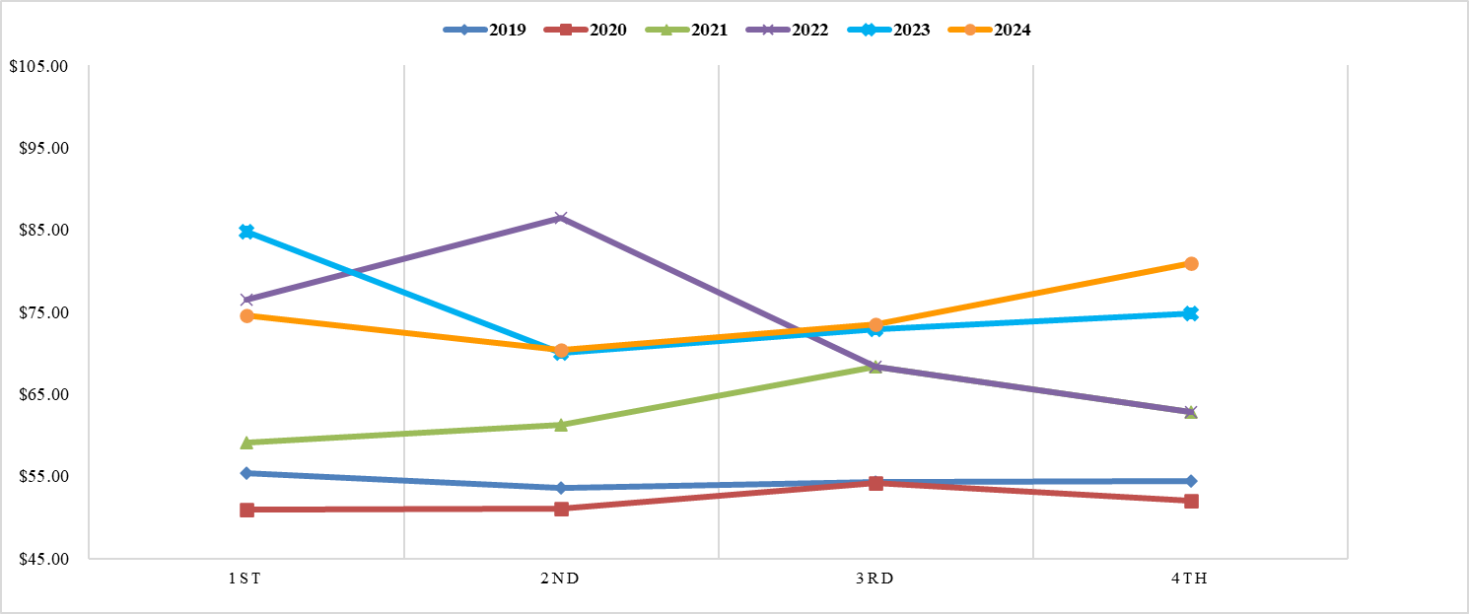

* The total gas bill includes the Cost of Service and Cost of Gas.

Chart of total bill average historical data by quarter for 2019 to 2024

**TABLE 3 – COST OF GAS COMPARISON**

Table of cost of gas comparison for January to June 2024

**CHART 3 – COST OF GAS COMPARISON**

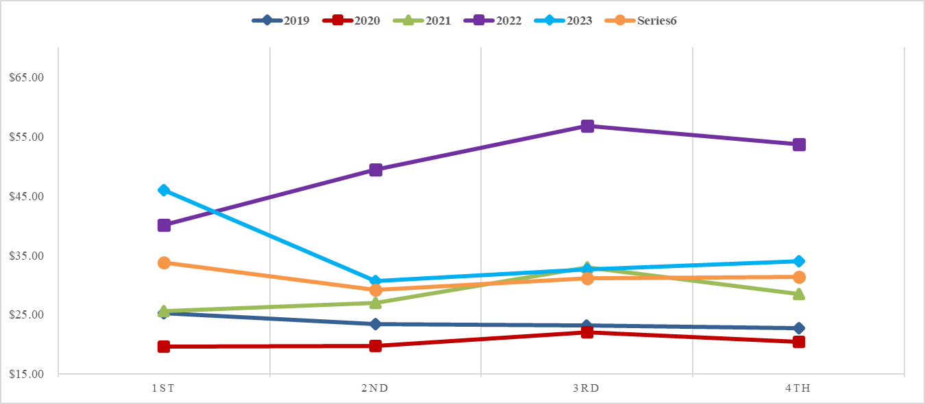

Chart of cost of gas historical data by quarter for 2019 to 2024

**CHART 3A – 6 MCF COST OF GAS AVERAGE BY YEAR**

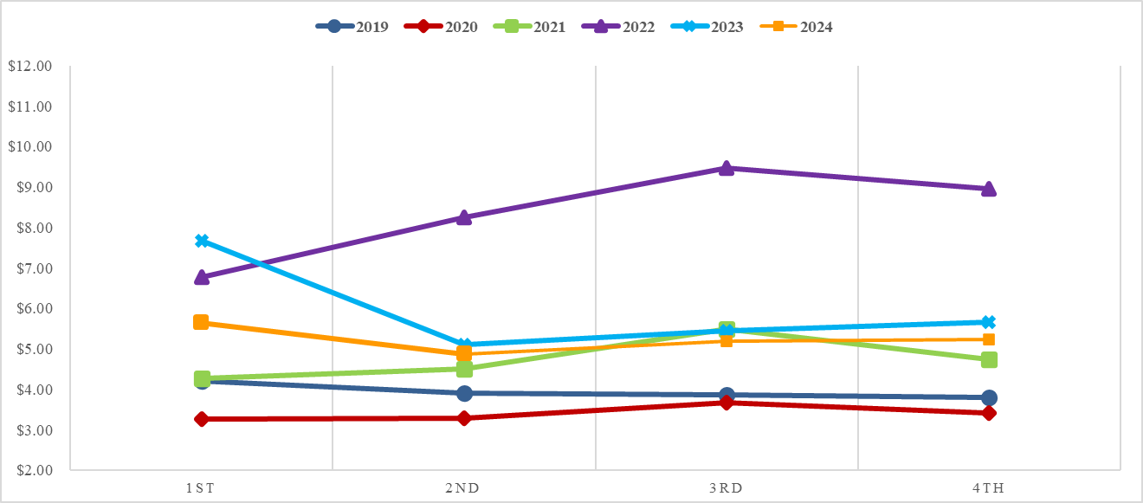

Table of 6 MCF cost of gas average by quarter and year 2019 to 2024

**TABLE 4 – COST OF SERVICE COMPARISON BY MONTH**

Table of cost of service comparison by month for January to June 2024

**CHART 4 – COST OF SERVICE AVERAGE BY YEAR**

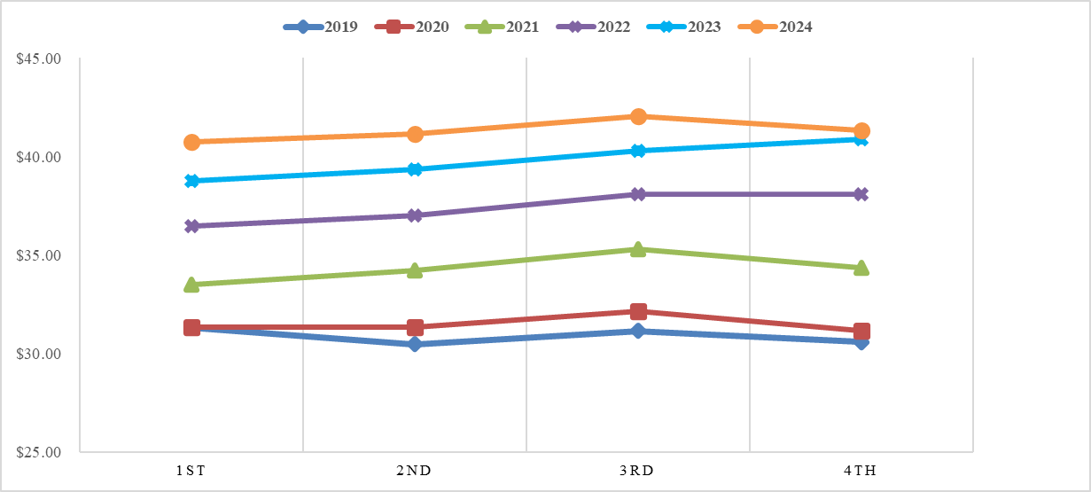

Chart of cost of service data average by year and quarter for 2019 to 2024

**TABLE 5A – COST OF SERVICE AND COST OF GAS DATA**

Chart of cost of service and cost of gas data for January to June 2024

**TABLE 5B – COST OF SERVICE AND COST OF GAS DATA CONT.**

Chart of cost of service and cost of gas data for January to June 2024 continued